A Parent's Guide to Synergy ParentVUE
Please contact the school secretary to obtain an activation key to allow access to ParentVUE. Once you have your activation key, use the following instructions to set up your account:
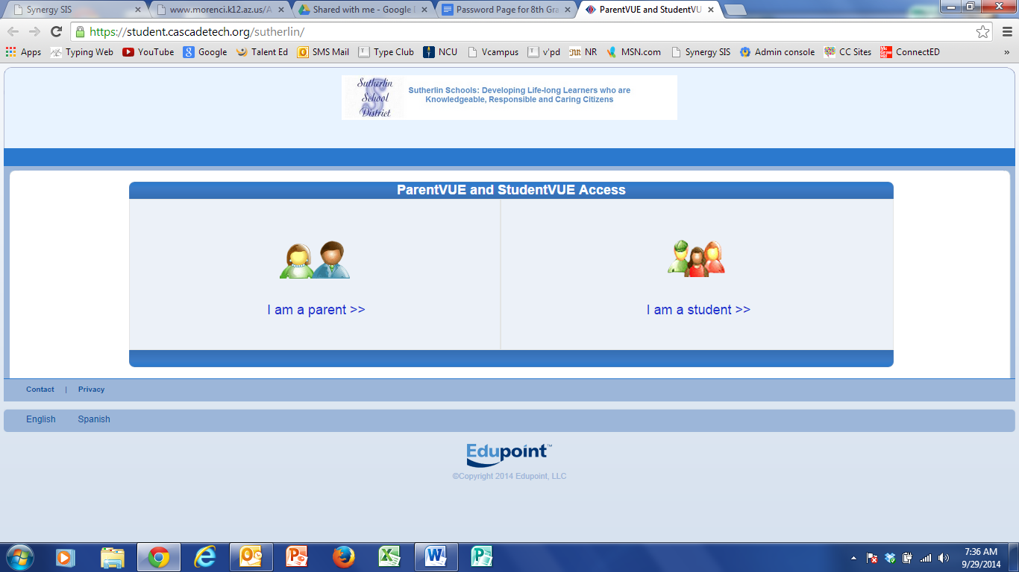
First, Create an Account
- Get an Activation Key from the office staff
- In the web browser, go to https://sis-sutherlin.cascadetech.org/sutherlin
- Click I am a Parent
- Click I have an activation key and need to create my account.
- Read the Privacy Statement and click I Accept.
- Enter your name and activation key. Click Continue to Step 3.
- Choose a user name and password (at least 6 characters), provide an email address, and click
Complete Account Activation

Later Access: Log In
- In your web browser, go to https://sis-sutherlin.cascadetech.org/sutherlin
- Click I am a parent.
- Enter your User Name and password, and click Login.
Mobile Apps
- Download the ParentVUE iPhone apps from the iTunes Store.
  - https://itunes.apple.com/us/app/parentvue/
  - Compatible with iPhone, iPod touch, and iPad.
- Download the ParentVUE Android apps from Google Play
  - https://play.google.com/store/apps/details?id=com.FreeLance.ParentVUE
  - Compatible with phones and tablets running Android 2.1 or later
NOTE: ParentVUE accounts cannot be activated on Mobile apps

